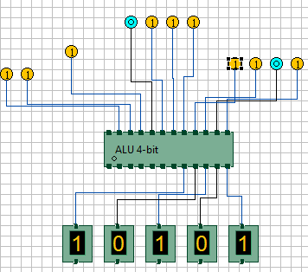
FIG:8 ADDER
A=1101 B=0111 SELECT_LINES=11 SUM=0101 CARRY=1

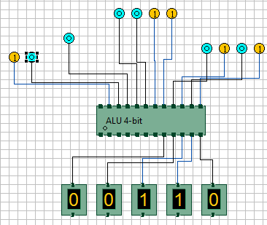
FIG:7 EXOR OPERATION
A=0101 B=0011 SELECT_LINES=10 OP=0110 CARRY=0
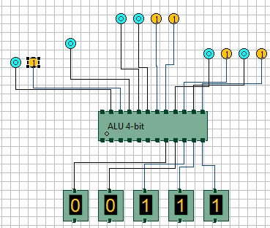
FIG:6 OR OPERATION
A=0101 B=0011 SELECT_LINES=01 OP=0111 CARRY=0

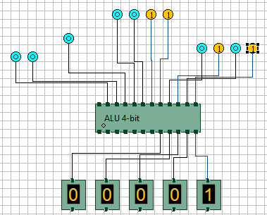
FIG:5 AND OPERATION
A=0101 B=0011 SELECT_LINES=00 OP=0001 CARRY=0

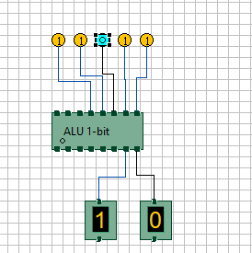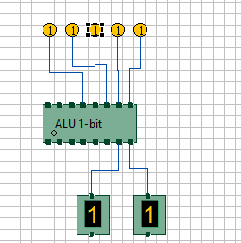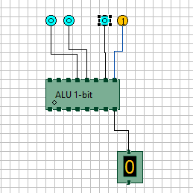
FIG:4a ADDER FIG:4b ADDER FIG:1 AND OPERATION
A=1 B=1 C0=0 A=1 B=1 C0=1 A=1 B=0
SELECT_LINES=11 SELECT_LINES=11 SELECT_LINES=00 OP=0
SUM=0 CARRY=1 SUM=1 CARRY=1

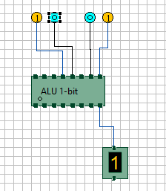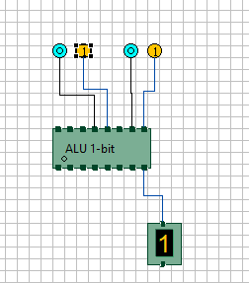
FIG:3 EXOR OPERATION FIG:2 OR OPERATION
A=1 B=0 A=1 B=0
SELECT_LINES=10 OP=1 SELECT_LINES=01 OP=1

